Modification of HDK 20190520

1. **32.768KHz crystal**

|  |  |
| --- | --- |
| Target Boards | D3F, D3FP, D3FV, COB |
| Modification | The capacitor for 32.768KHz crystal should be less than 9 pF |
| Description | To avoid the startup issue of 32.768KHz crystal when PMU_SF is low. The capacitor for 32.768KHz crystal should be less than 9pF to increase the loop gain of crystal circuit. |

Schematic:



1. **PWR_EN**

|  |  |
| --- | --- |
| Target Board | D3F, D3FP, D3FV, COB |
| Modification | Remove the capacitor of PWR_EN and change the pull up resistor to 100K ohm. |
| Description | There are 2 way to use PWR_EN pin.   1. PWR_EN and VBAT rise at the same time. PWR_EN voltage should follow the VBAT when power on. That’s why the capacitor is removed. 2. PWR_EN rise after VBAT is ready. In this case, the rise time of VBAT should be less than 500ns.   Therefore, removing the capacitor to increase the rise time of PWR_EN.  To avoid the bounce of the PWR_EN, the pull up resistor is change to 100K ohm. |

Schematic:



1. **RST_N**

|  |  |
| --- | --- |
| Target Board | D3F, D3FP, D3FV, COB |
| Modification | Keep the resistor and capacitor of RST_N |
| Description | The time of VBAT rising to RST_N rising is 2ms, so we keep pull-up resistor and the capacitor. |

Schematic:



1. **WP and HOLD pins of Flash**

|  |  |
| --- | --- |
| Target Board | COB |
| Modification | Remove pull up resistors and pull them up by GPIO |
| Description | To access the flash, Boot rom will read the flash device information to determine if a flash is a single bit or quad bit type. The WP and HOLD should be high in the beginning.  To support Standard SPI (single bit) feature  WP and HOLD pins should keep high when reading SPI flash.   1. In IO limited design –   Use external pull high resistor for WP & HOLD signals   1. No IO limit design -   Use internal pull high resistors in GPIO16(as WP) and GPIO17(as HOLD)  To support Quad SPI feature  All 6 IO pins of the flash have to be connected to OPL1000 |

Reference design schematic:

🡺 In IO limited design

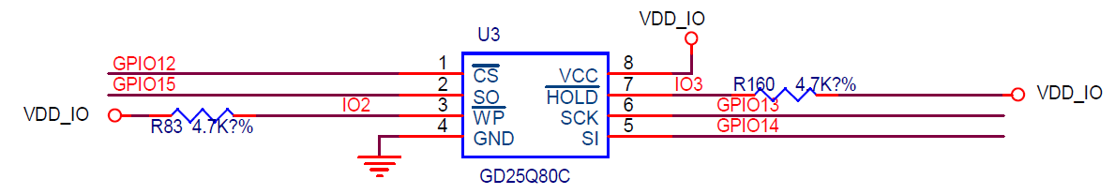

🡺No IO limit design

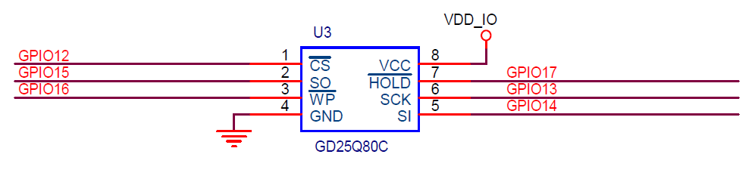

1. **Decouple capacitors**

|  |  |
| --- | --- |
| Target Board | COB (with external LDO only) |
| Modification | Decide what decouple capacitors can be removed |
| Description | There are decouple capacitors for following power domain: VDD_RF, EX_DCDC, VBAT, VDDC. According to below performance test, the capacitor of VBAT, VDDC, EX_DCDC can be removed. The removing of decouple capacitors for VDD_RF depends on the requirement of RF performance. If the lower performance is accepted, decouple capacitors for VDD_RF can be removed, too.  Note: removing decouple capacitors are only for external LDO. |

